|  |  |
| --- | --- |
| Lab 15 | |
| **Topic** | **Flip Flop conversions** |
| **Software** | * Circuit Maker 2000 |
| **Objective** | * To understand working of gates * To Validate the above implementation using Circuit Maker |
| **Reg. #** |  |
| **Name** |  |

**Flip-Flop conversion**

**Important steps for Flip-Flop conversion**

**Step 1:** Identify the available and required flip flop.

**Step 2:** Make excitation table for available flip flop.

**Step 3:** Make characteristic table for required flip flop.

**Step 4:** Write Boolean expressions for available flip flop.

**Step 5:** Draw the circuit diagram.

**General Steps for Conversion:**

1. **Select target flip-flop type** (e.g., D flip-flop).
2. **Use excitation table** of the flip-flop you have.
3. **Use characteristic table** of the flip-flop you want.
4. **Make a truth table** matching present state & required next state.
5. **Find expressions** for inputs of the given flip-flop using K-maps (if needed).

Task 1:

1. By using conversion techniques, provide the step wise solution for **JK flip-flop to SR flip-flop** conversion.
2. Implement on circuit maker.

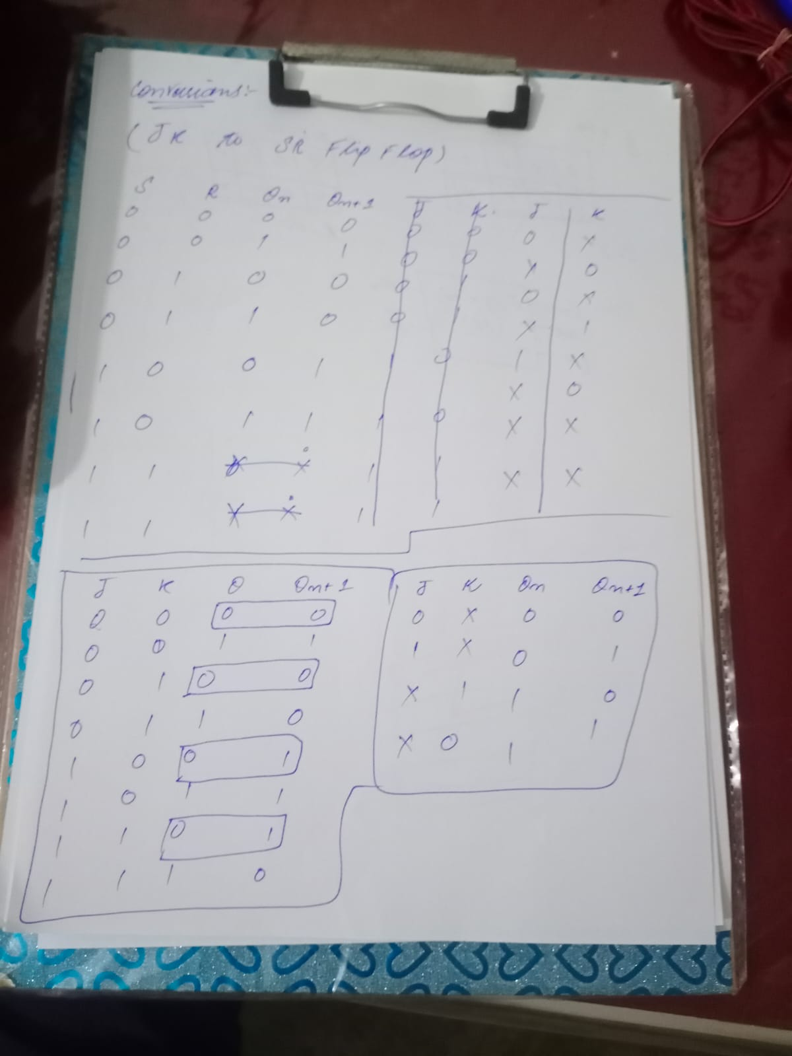

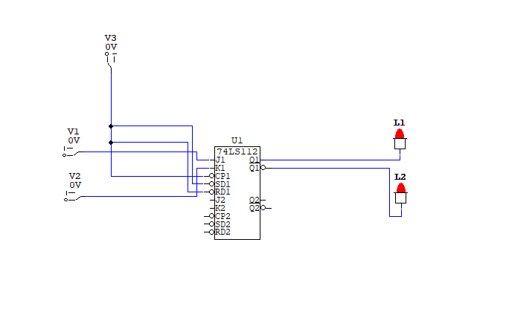

## Task 2:

1. By using conversion techniques, provide the step wise solution for **JK flip-flop to D flip-flop** conversion.
2. Implement on circuit maker.

## Task 3:

1. By using conversion techniques, provide the step wise solution for **JK flip-flop to T flip-flop** conversion.
2. Implement on circuit maker.